JUNE 2021(Group Room 2)
Sunday | Monday | Tuesday | Wednesday | Thursday | Friday | Saturday
Letter  Theme of the week  Transportation | May 31  Art Activity  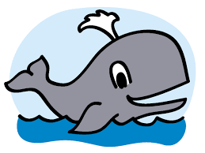  CAMRYN | 1  Art Activity  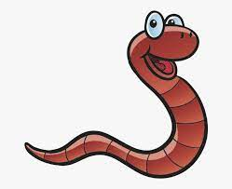  BEAU/FELIX | 2  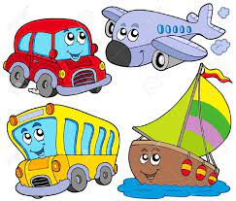  DESMOND | 3  Watermelon  ALEX/TIMUR | 4  Wacky Hair Day  Come to school with wacky hairdo  LUCAS/ARLO | 5
6  Letter  Theme of the week  Transportation | 7  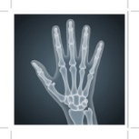  X-Ray  JOSEPHINE/JOANNE | 8  Science experiment  Pepper and Soap  ISLA/LYLA | 9  Freezie Day  BRIXTON | 10  Wear your favorite  Sports Jersey  GRAYSON | 11  LEVI/MAREN | 12  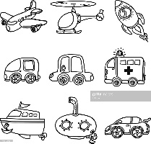
13  Letter  Father’s Day Week | 14  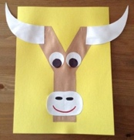  Yak  LAYLA | 15  Storytime  My Daddy  and Me  JACKSON | 16  Storytime  Just Grandpa and Me  EMILY/ROY | 17  Dress Up in your favorite superhero  THOMAS | 18  White T. Shirt  Day  Wear a white T. Shirt | 19
20  Theme of the week  Space | 21  Letter Z  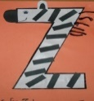 | 22  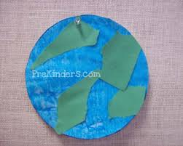  Earth | 23  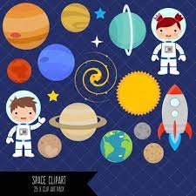  Solar system | 24  Bring your favorite toy to show and play | 25 | 26
27 | 28  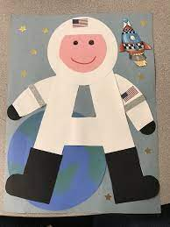  Astronaut | 29  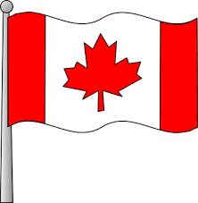  Wear Red and White | 30  PACK A COLD LUNCH |  | Kidzone Closed  Thursday 1st July  To Friday 9th July 2021  Reopen  Monday 12th July, 2021
*SHOW AND TELL, PLEASE CHECK FOR YOUR CHILD’S NAME.

